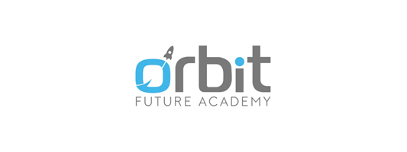

AI mastery (SKS & jam pelajaran) :

1. Artificial Intelligence Foundation: 90 jam (2 sks)

2. Python Foundation: 90 jam (2 sks)

3. Berkolaborasi dengan Git: 30 jam (1 sks)

4. Machine Learning & Deep Learning: 90 jam (2 sks )

5. Data Science: 100 jam (2 sks )

6. Natural Language Processing: 100 jam (2 sks)

7. Reinforcement Learning: 100 jam (2 sks)

8. Computer Vision: 100 jam (2 sks)

9. Deployment/Final Project: 200 jam (5 sks)